NexStar 4 (or any NexStar?) – Hand Controller (HC) LCD replacement.
This information is supplied ‘as is’ – I cannot provide support for fixing your faulty HCs short of what is provided here.
I’m by no means a great astronomer short of the fact that I like dragging my little NexStar 4 out occasionally to have a relaxing time scooting about the sky.
About two years ago the display started intermittently not showing any text, the backlight was fine but screen was blank. I did the usual of cleaning the ribbon but it made no difference, eventually it failed all together. The controller seemed to be working fine, movement control, etc.)
As a person with knowledge of the ways of the soldering iron, I thought I’d have a go at my own fix. I figured it was a standard LCD connection but the display itself was a rather specialized, slimline glass type that I could not seem to find anywhere (don’t tell me you know exactly where to find them! 😉)
After a bit of thought I reverse engineered the display interface of the HC and connected my own LCD display, designed a little clip-on box to hold it and got the telescope back in business.
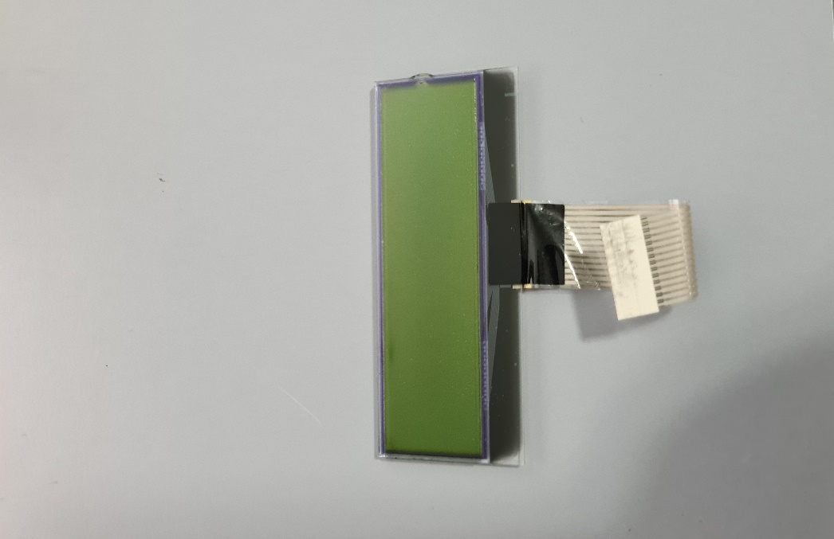
This is the original LCD ‘on glass’ display. I did try but could not find a direct replacement. It, along with the backlight, are removed. Keep the protective display label.

What follows is a short description, a diagram of the circuit and links to the 3D printer files to accommodate a replacement (and larger) LCD.
I first experimented to get the circuit shown, a little bit of logical observation with trial and error to sort out the control signals. The original (and new) LCD is a standard HD44780 interface, a 1602 display (16 Characters x two lines).
It took me quite a bit of searching to find an LCD with a red text on black background. The testing was done with a green LCD. Here is the source and part number for the red LCD I ended up with:
https://www.ebay.com.au/itm/393194797044?var=662396589208
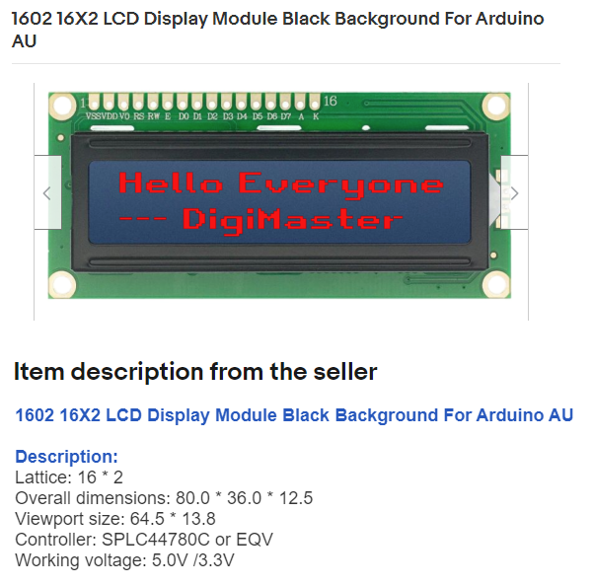
You might want to use the details from this listing (valid as of Feb 2023) to source a suitable LCD in your part of the world. It looks like Digikey sells a similar LCD but check the physical details on any LCD you buy beforehand, using the dimensions on the 3D printed case to check, but I think these displays are generally the same dimensions.
I first used a breadboard to duplicate the driver circuit and get the idea working while protecting the driver in the HC:
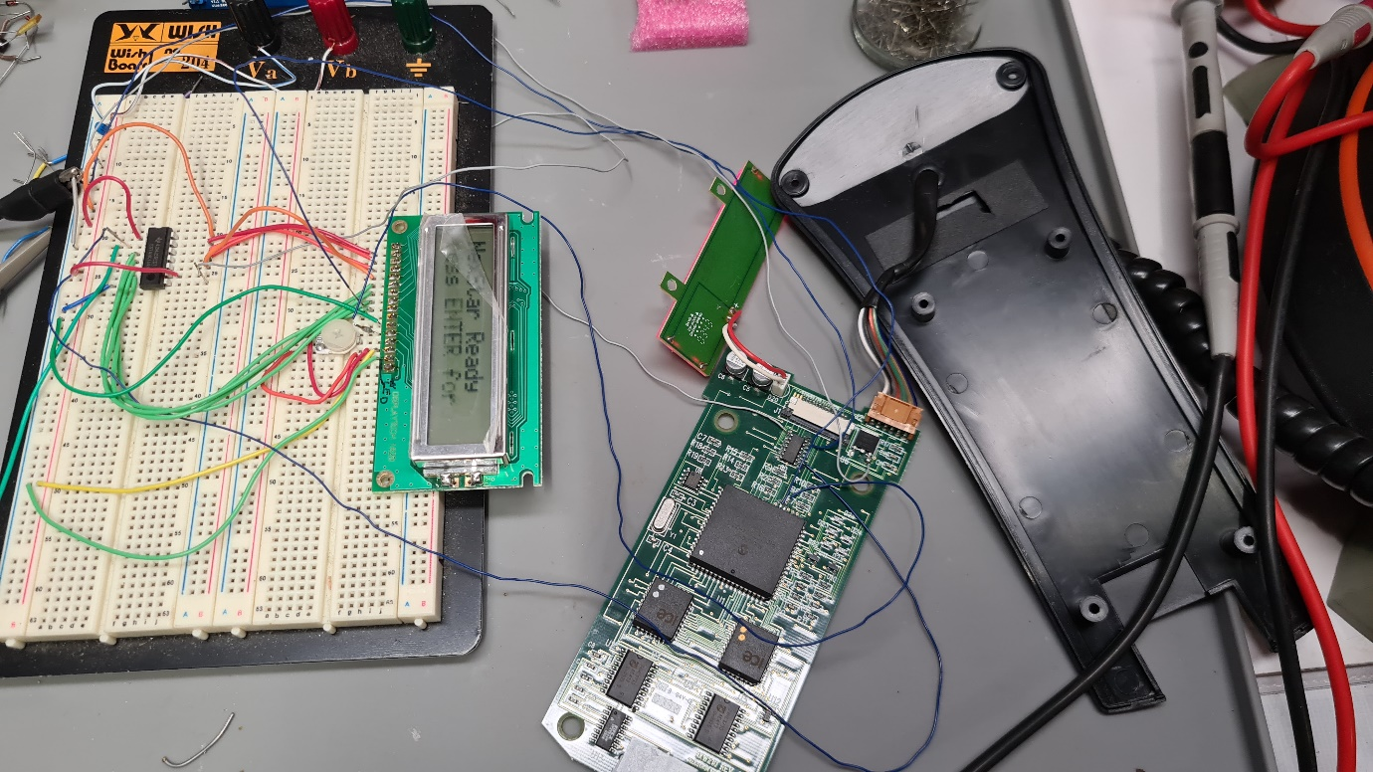
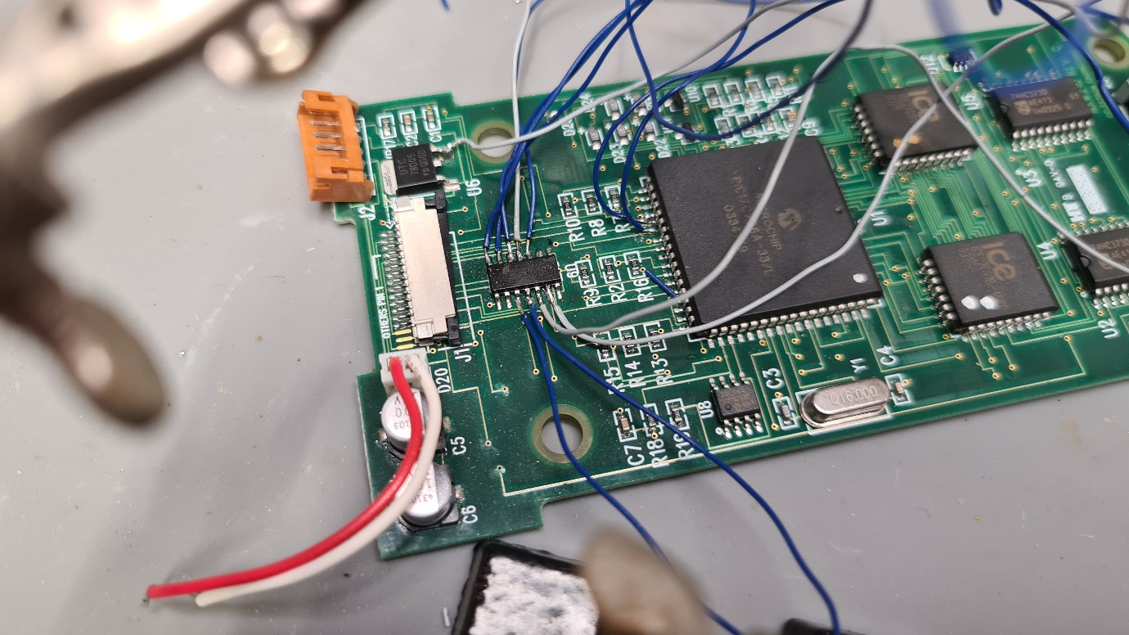
Details of the wire connections that would ultimately be secured with hot melt glue.
That little chip is the 74HC164, I replicated this on the breadboard but in the final solution, I used the original one in the HC. The red and white wire are the supply for the LCD backlight (R =+5V, Wh = 0V)
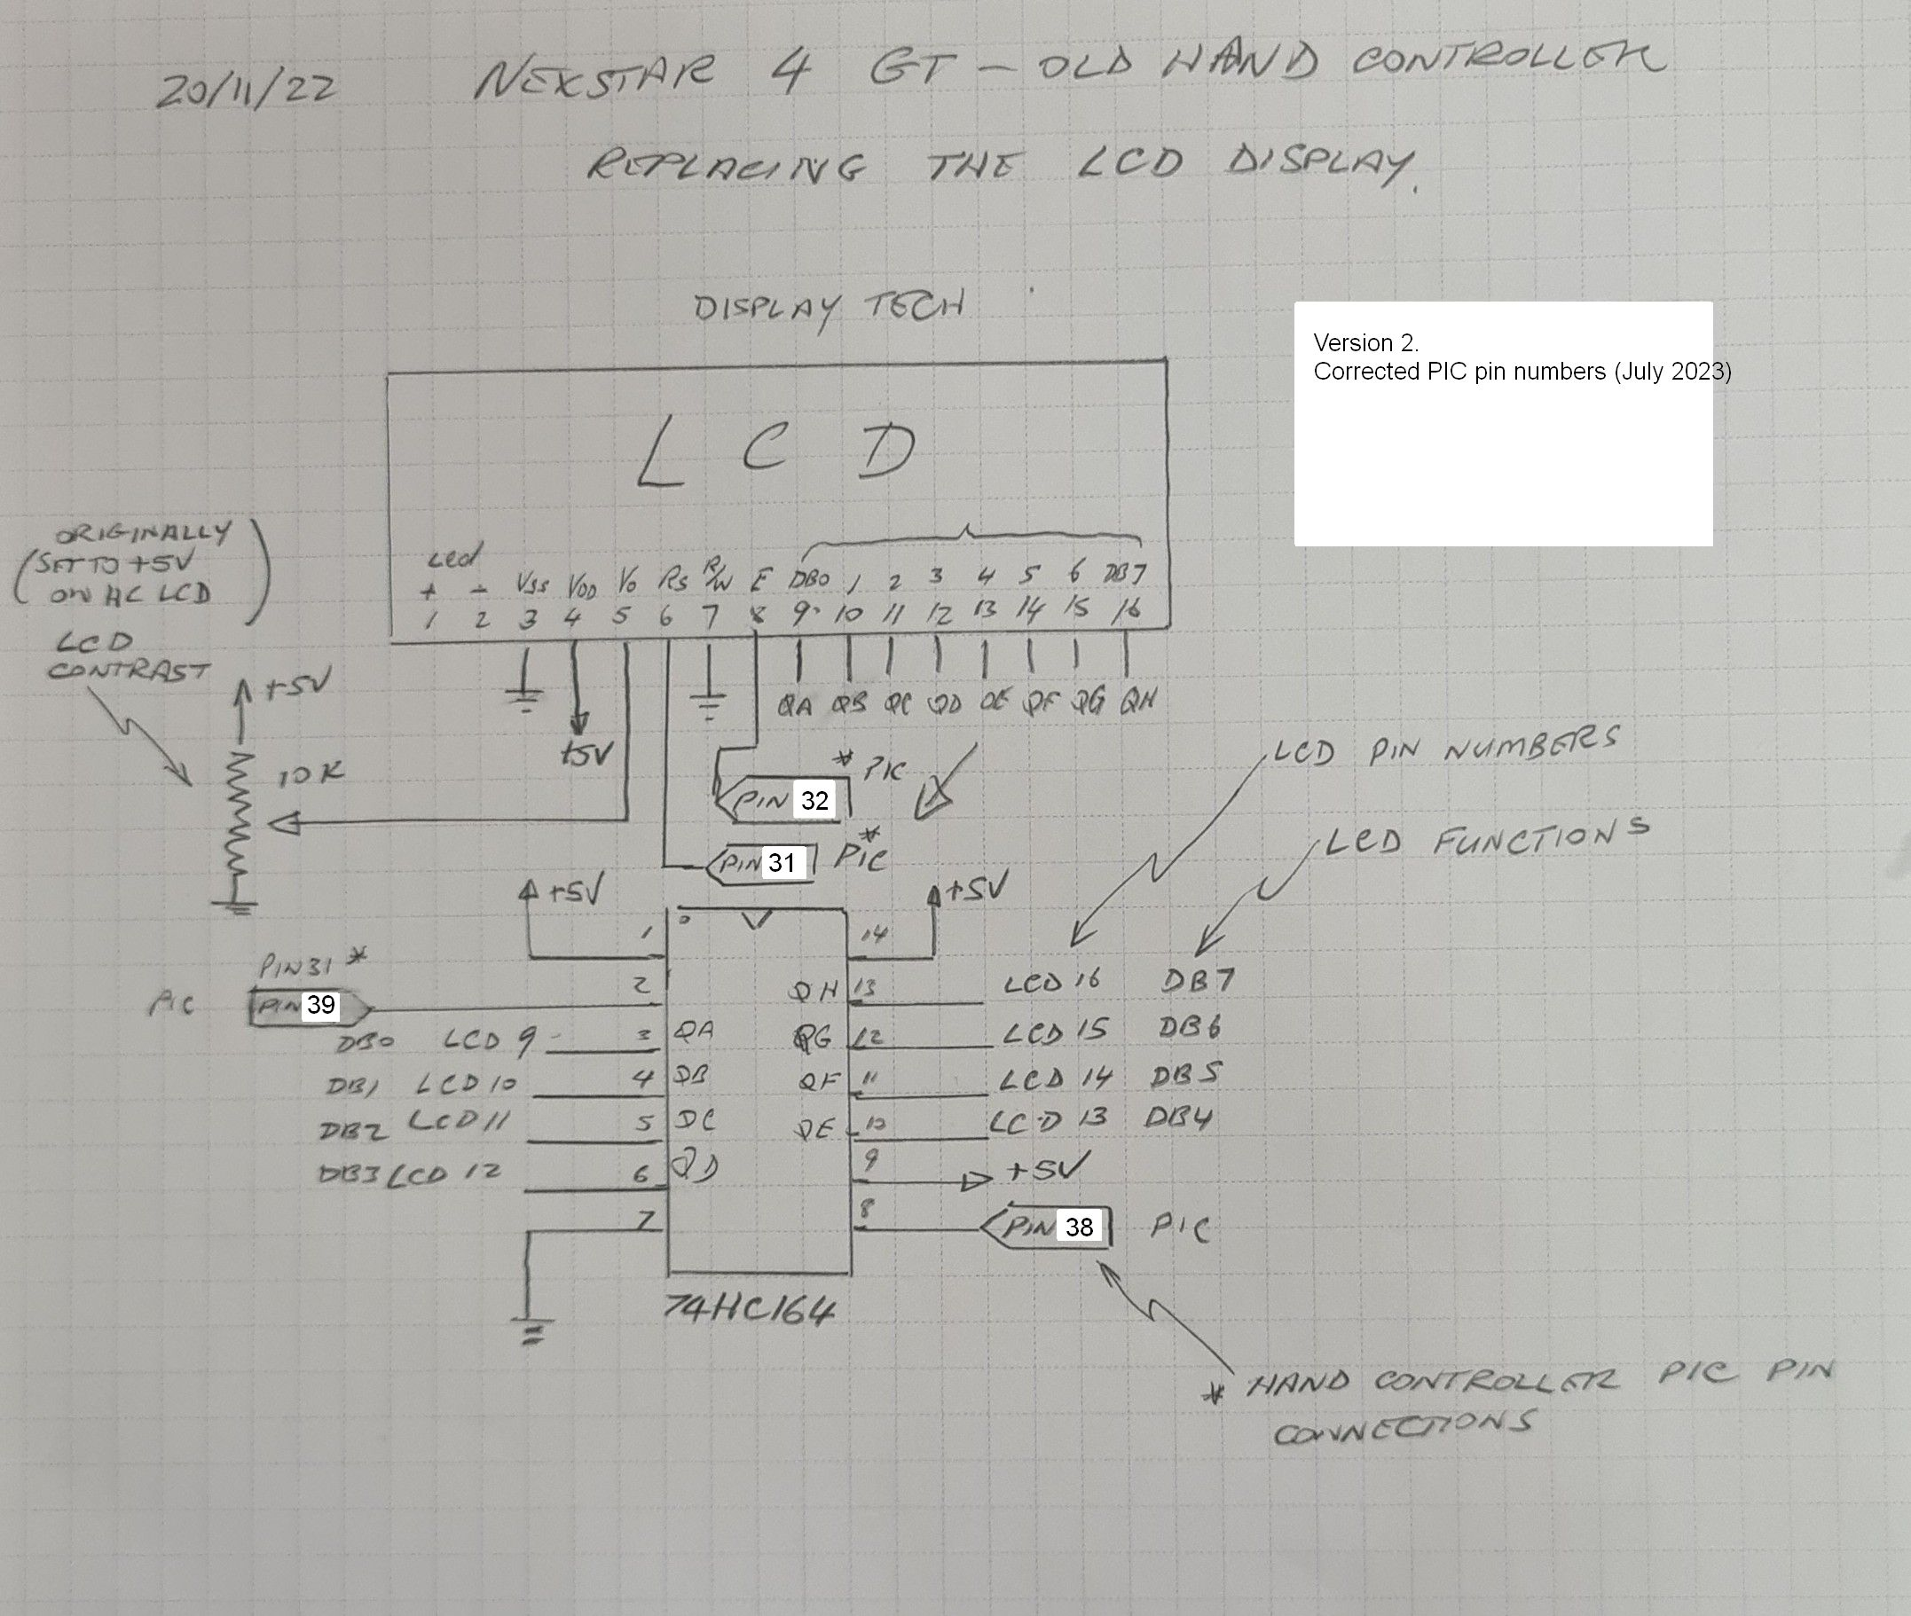
Here is the final reverse engineered circuit. The *PIC designations refer to the pins on the large square PIC chip on the HC. The 74HC164 is also on the HC and the LCD wires were directly soldered to the chip. The only added components were the new LCD display and housing and the LCD contrast pot.
The LCD contrast was driven directly from the HC but I replaced it with the 10k trimpot.
Also – check your replacement LCD pinout, there is a standard but the LED backlight pins can move from one side of the connector to the other depending on the manufacturer.
As you can see, this requires some experience with soldering and electronics.
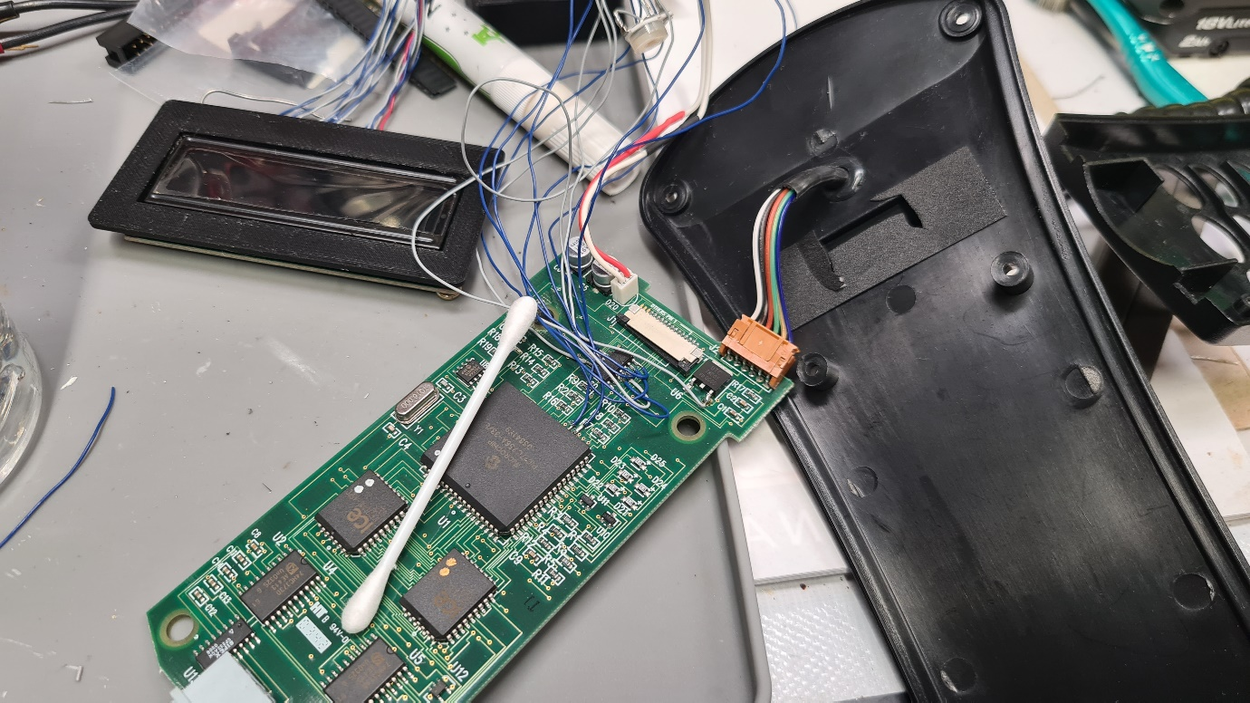
The HC connected to both the LCD, inside its 3D printed housing and the NexStar 4.

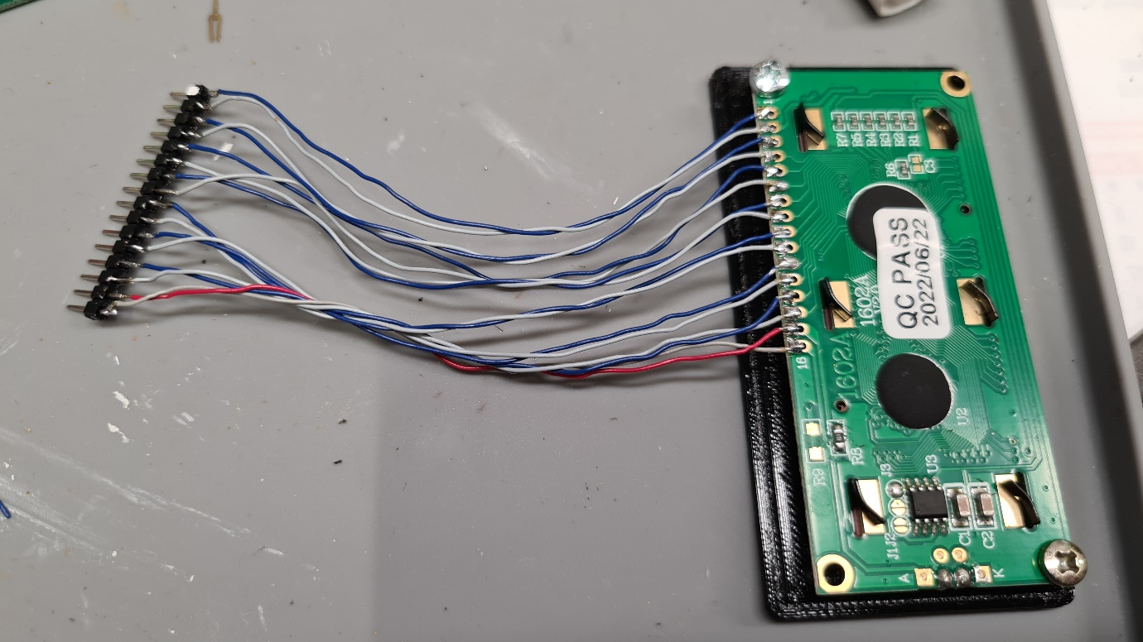
I decided to put a connector between the LCD and HC board, but you can hard-wire it.
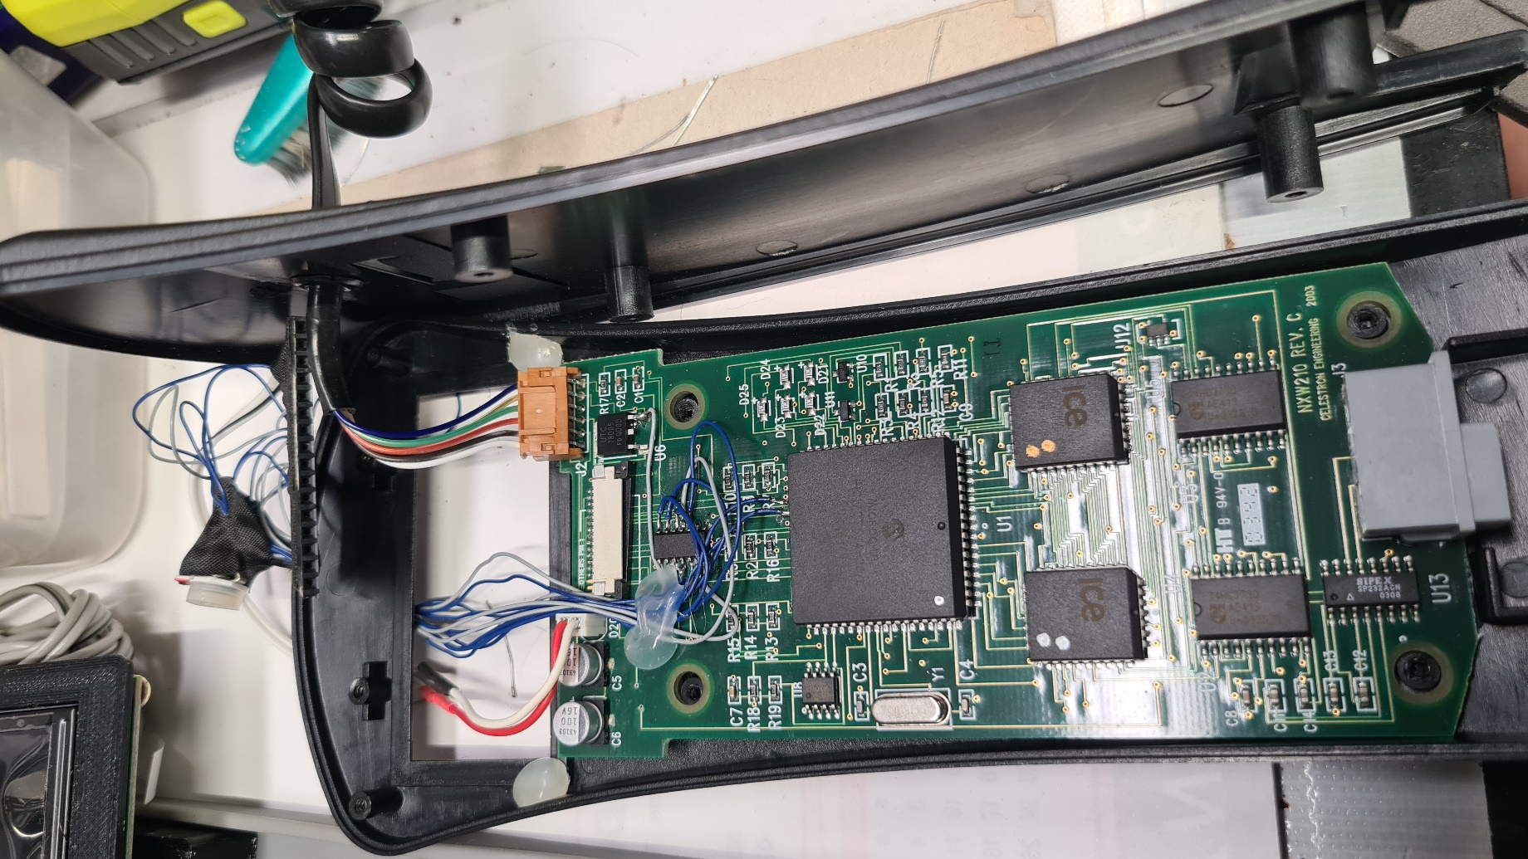
There’s the trim pot at the top covered in black cloth tape. And the hot glue securing the wiring to the PCB. The black chip at top right is a 5V voltage regulator (a good place to get +5V from).
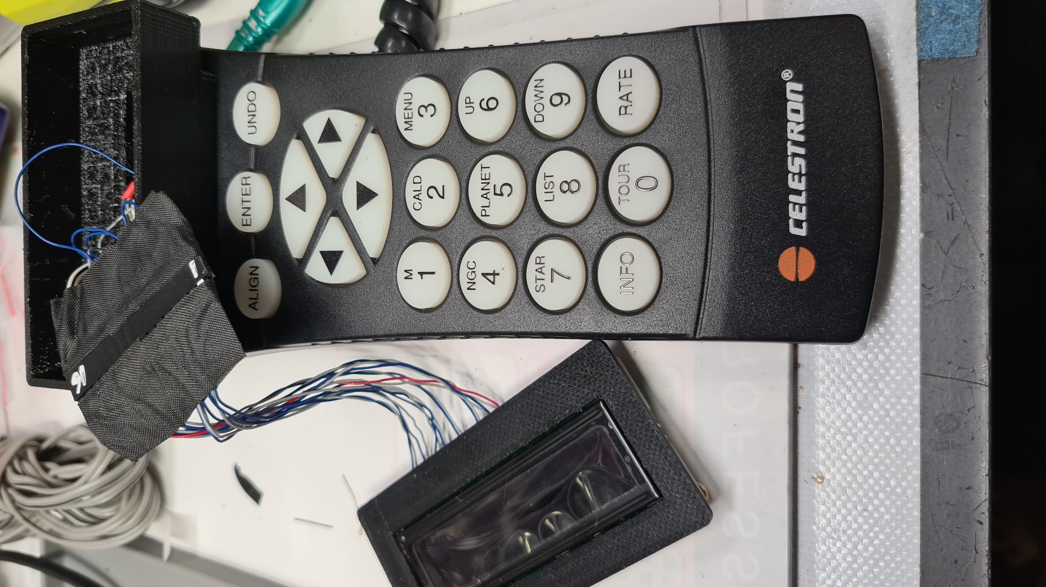
The mounted LCD and protected connector. The LCD housing can be seen clipped into the original LCD hole. The original display protection sticker can be stuck over the new LCD to give it a neater finish and stop backlight bleed.
What follows are multiple views of the finished project (including my finger). The phone camera picks up a higher LCD contrast that is actually there. The 10k trimpot adjusts from no display to over saturated display – remember that if it all appears to be not working.
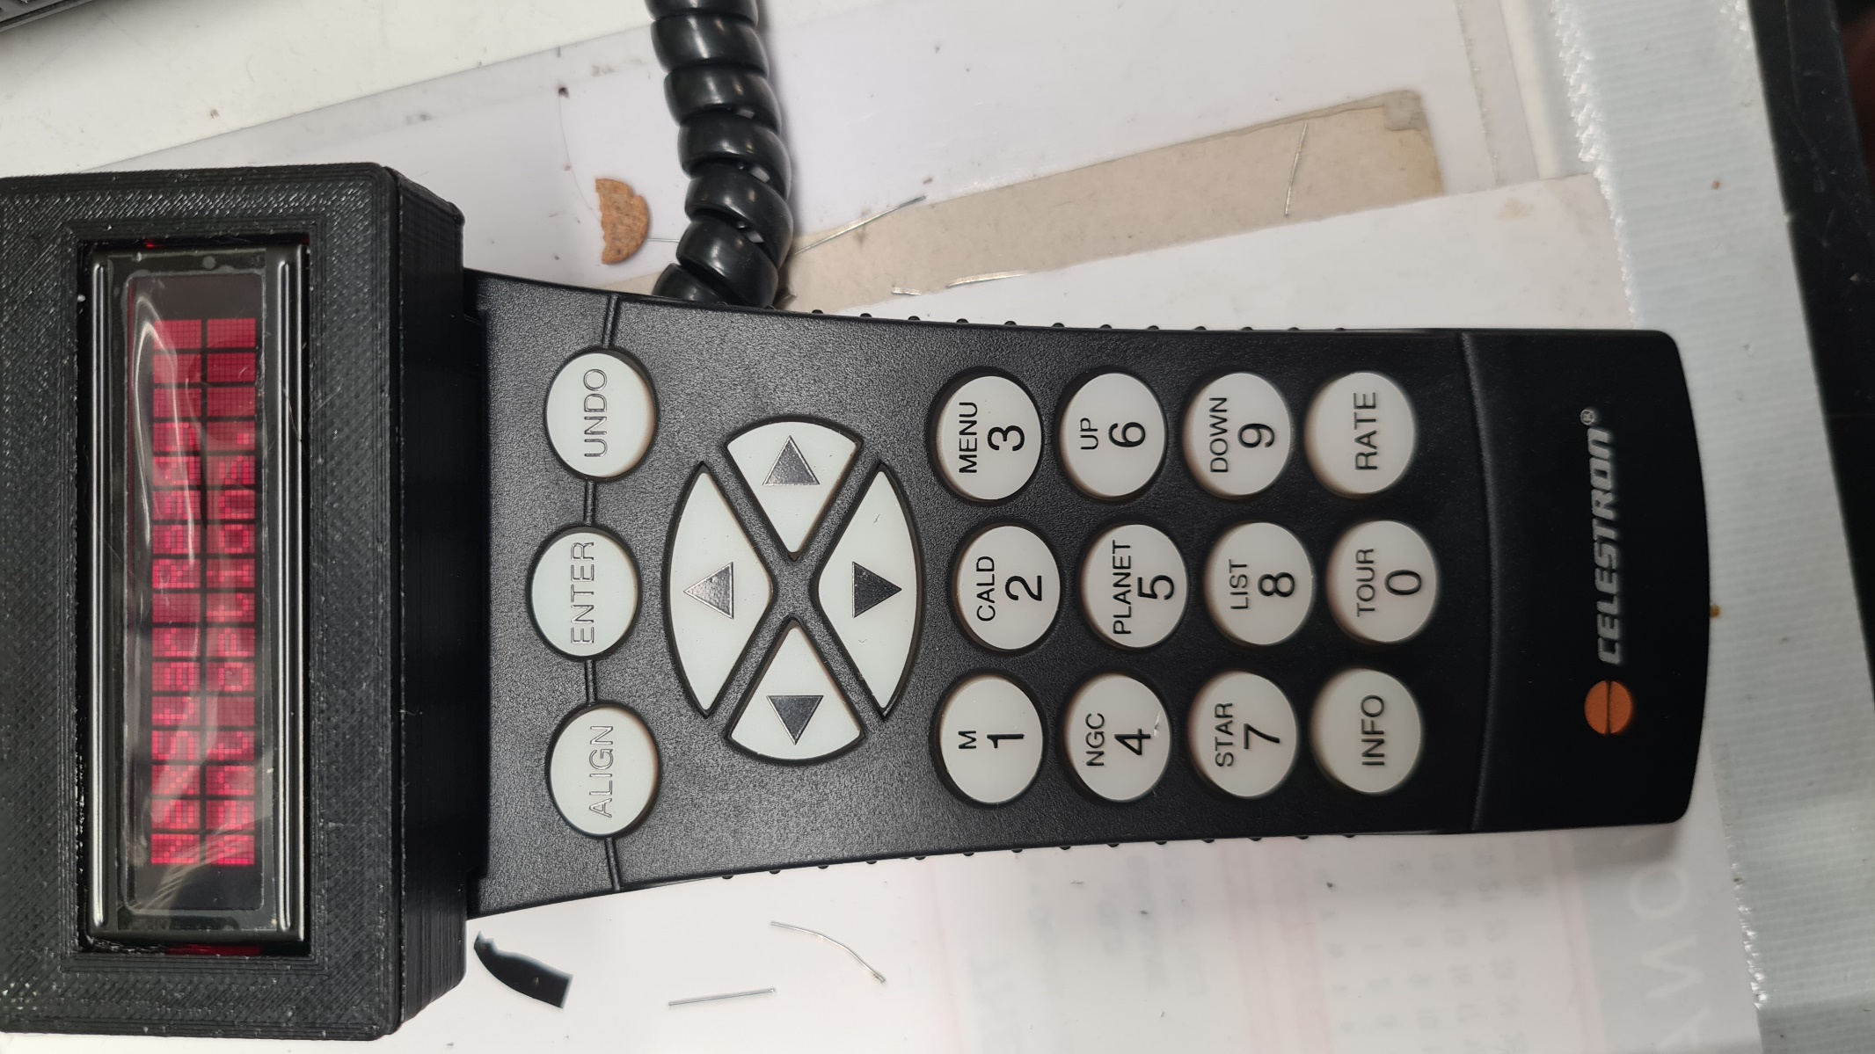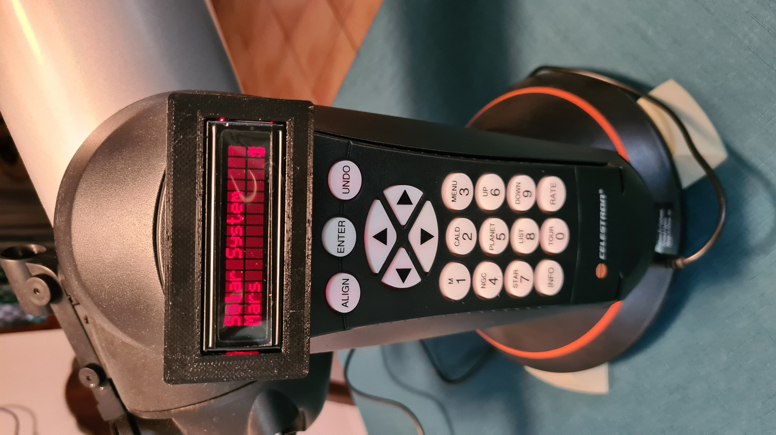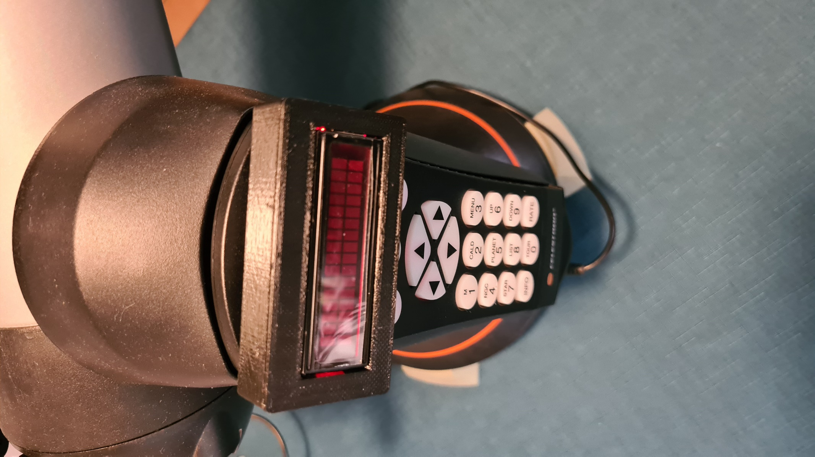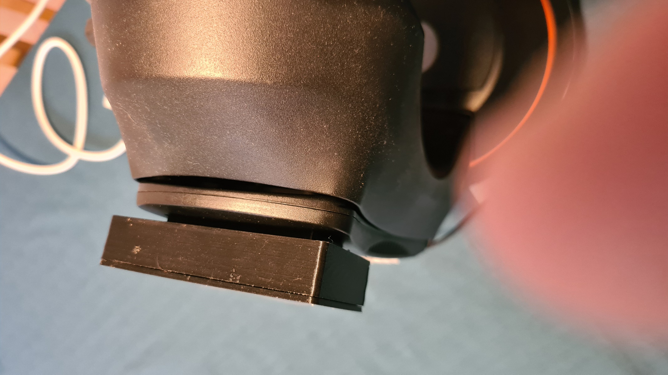
The final design just uses an LCD display hardwired (via a SIP connector in my case but you can leave this out) with fine wire to the hand controller board.
The new display would not fit into the hand controller, so I designed a 3D printed housing to clip into the old LCD opening. For different 3D printing tolerances - you may require adhesive for a loose housing or a little bit of filing for a tight one, my print is a friction fit into the opening.
Here are two links for the 3D printer files (both hosting sites have the same files):
https://www.thingiverse.com/thing:5873400
https://www.printables.com/model/409518-nexstar-hand-controller-lcd-replacement-housing

I’m happy to say the controller is now displaying nicely and has been out in the backyard for a few viewing sessions without a hiccup (except for the usual eccentricities of the NexStar 4GT)
Good luck and hope this info helps some people out.

Robert Googe

